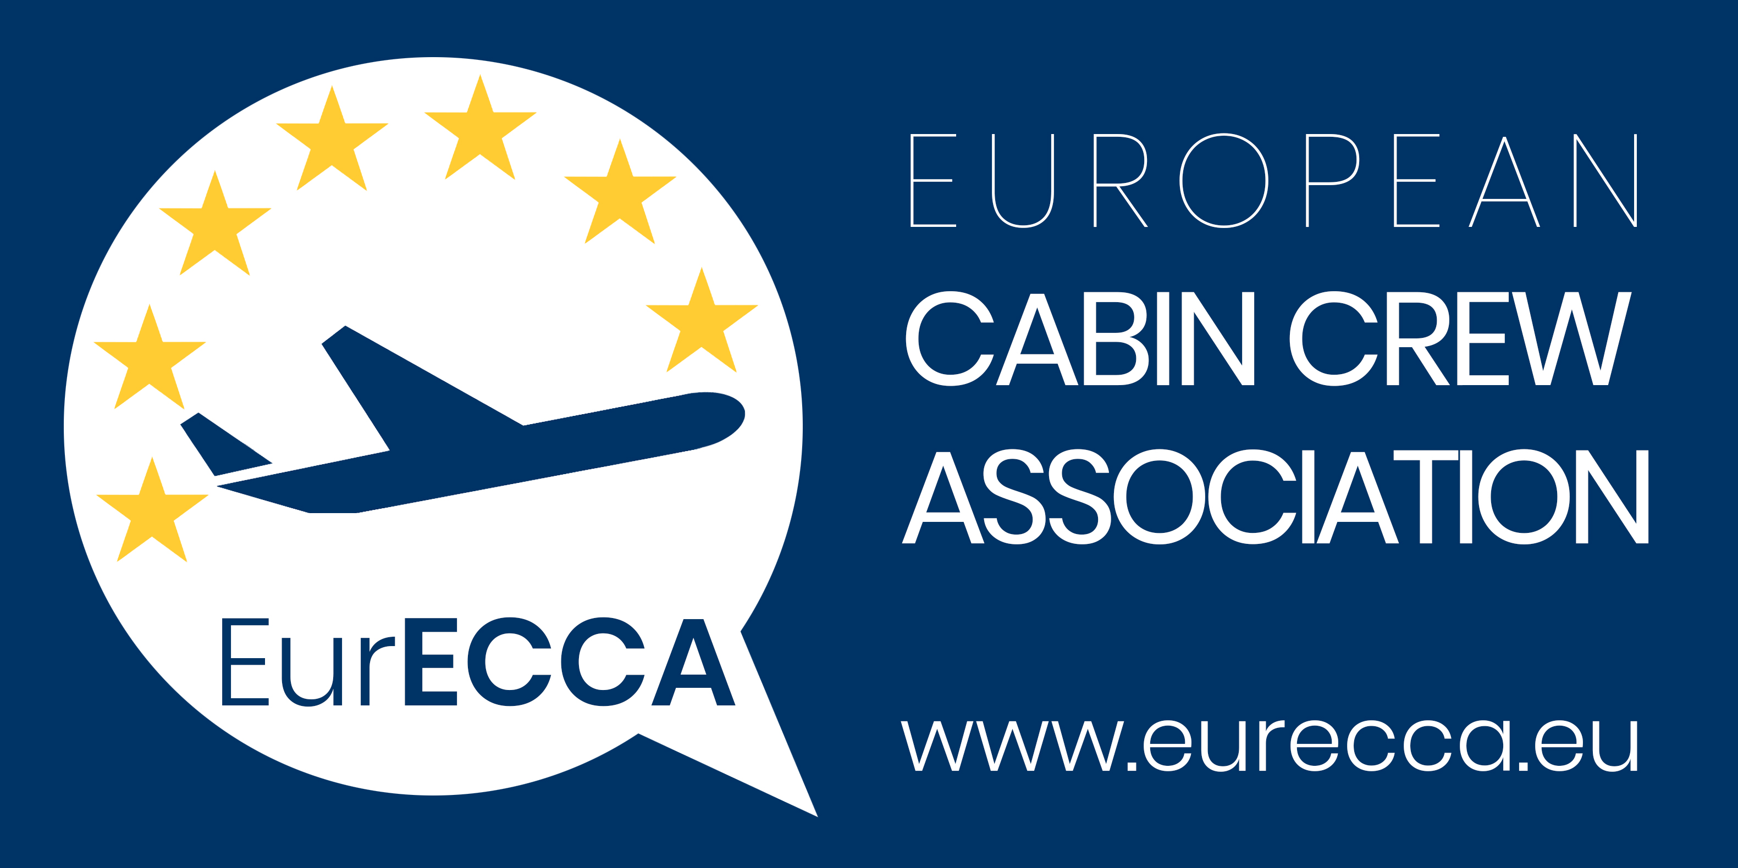

Position Paper

Brussels, 23 February 2021

EurECCA in favour of a further temporary suspension of slot utilization usage rules

EurECCA in favour of a further temporary suspension of slot utilization usage rules as the air transport sector needs more time to return to pre- COVID flows.

EurECCA welcomes the new resolution, adopted on 11 February 2021 amending European Council Regulation (EEC) No 95/93. The European Commission’s new resolution seeks to support airlines by temporarily suspending slot usage rules until summer 2022.

EurECCA hopes in a huge parliamentary sustain to confirm it: the slow return to a normal situation in air transport must either the reintroduction of competition in the allocation of airport slots and the historic rights of certain airlines.

Our sector has suffered greatly due to the pandemic and this resolution would be one measure to help rebuild it. Alongside this a package of specific aids (e.g. introduction of a Travel Pass, common borders rules etc) are needed to boost a return to normal.

EurECCA represents, protects and develops the rights and needs of cabin crew all over Europe

